**Narsee Monjee Institute of Management Studies**

**Name: Vivek Gupta**

**SAP ID: 77115001807**

**Title:**

**ICT strengthened Decentralized Supply-chain for Farm-Produce**

**Acknowledgements:**

*I would like to express my special thanks of gratitude to* ***Professor. Ganesh Ramakrishnan*** *as well as our team who gave me the golden opportunity to do this wonderful project on the topic* **ICT strengthened Decentralized Supply-chain for Farm-Produce***, which also helped me in doing a lot of Research and I came to know about so many new things I am really thankful to them.*

*Secondly I would also like to thank my friends who helped me a lot in finalizing this project within the limited time frame.*

**Table of Content**

**1. Abstract………………………………………………………………………………………...3**

**2. Introduction…………………………………………………………………………………....4**

**3. Centralized VS Decentralized marketing System……………………………………………5**

**4. Agriculture Marketing Information System………………………………………………....5**

**5. Farmer Producer Company…………………………………………………………………..6**

5.1 Evolution Process of Producer Companies

5.1.1 ICT Based Direct Marketing Solution

**6. Requirement Gathering……………………………………………………………………….8**

6.1 Case study of Business Model

6.1.1 Abhinav Farmers Club (AFC)

6.1.2 Krishi Vikas Farmer Producer Company (KVFPC)

6.1.3 Healthy Harvest Farmers organization

6.1.4 Mumbai Sulins

**7. Existing System Flow for Farmers Marketing Product/Information Flow**……………….**11**

**8.** **Representation of Proposed Mobile Application**…………………………………………...**13**

**9. Representation of Proposed Web Application**……………………………………………...**15**

**10. Conclusion…………………………………………………………………………………...17**

**11. References…………………………………………………………………………………...18**

**1. Abstract**

One of the prominent reasons behind success of e-commerce web services in doing good business in India is due to direct marketing access to individuals. This avoids non-productive or redundant overheads incurred through middle men and hence reduces per unit price.

Majority of successful e-commerce software services deal with processed agricultural products and non agricultural products. This was possible due to information and communication technology and its increasing usage across the length and breadth of India. Information and Communication Technology (ICT) interventions have impacted more in the manufacturing and service sectors in India.

However, there is no reason to believe that a similar impact cannot be achieved in agriculture. There have been some centralized initiatives by government and private organizations in taking some alternatives in ICT to agriculture, especially through media such as emails, interactive voice response (IVR) systems as well as through text messages. However, there have been very few decentralized ICT services and initiatives that cater to farmer producer companies and cooperatives and none of them have awareness in the area of supply chain management.

This study reports a comparison of centralized and decentralized ICT interventions. Specifically, we present the case of our experience with an ICT enabled solution for complementing the supply chain of small farmers associations like farmers clubs (FC) and farmer producing companies (FPC).

Our solution is in the form of a mobile application with e-commerce and IVR features that help farmer producer companies directly market their agricultural products such as vegetables, fruits and grocery. Preliminary intervention results indicate that farmers will get benefit from such a robust tool in longer run.

**2. Introduction**

Agricultural land holding in India is gradually decreasing, with only 85 % of landholders having less than two hectares of land. Out of this, 66 % have less than one hectare due to steady population growth. For making small landholding based farming financially sustainable, the farmer should get daily income by selling his short turn-over products like vegetables and cannot wait for income from seasonal crops. Many such farmers do not have other options for livelihood and hence they prefer growing vegetables, flowers or raising milch-animals or poultry.

These farmers use conventional approaches to sell their produce to nearby places like APMC, mandi, the middle man, etc. The profit realization depends upon the supply demand cycle in the market. Often, the share of farmers in revenue generated is abysmally low due to the presence of middlemen. Many initiatives have been attempted to overcome this problem, e.g., direct marketing, contract farming, linkage with retailers/ processors/exporters and market oriented production. Lipton (2002) suggested to link small farmers with national or global markets in processing and marketing. Often times this gap is filled by initiatives like Self Help Groups, Joint Liability Groups, Farmer clubs, Farmer Federations, SHG Federations, Producer Companies, Producer cooperatives, etc. To promote direct interactions of producers with consumers in fresh produce, there have been farmers’ markets in India in the form of Apni Mandis in Punjab, Rythu Bazaars in Andhra Pradesh, Uzhavar Santhai in Tamil Nadu, and Shetkari Bazar in Maharashtra, promoted by state agencies. These are helping farmers in direct marketing of agro-produce for better price realization. These alternative channels of marketing are unable to sell complete products of the producer and have a limited number of farmers participating. In this mechanism the rates given to farmer are benchmarked by APMC.

The current government strategy facilitates the farmer through support prices and shops such as free power and farm loan waivers but is not enough to make them sustainable. A comparison of the income of a farmer with the poverty line for rural India shows that

(i) the average income of a farmer household dependent entirely on agriculture is only 58 % above the income specified by poverty line and

(ii) about 53 % of farm households in India will be living under poverty if they do not adopt high income-generating farm activities or earn some secondary income from nonfarm sources.

**3. Centralized VS Decentralized marketing System**

In a centralized marketing system which is general practice of marketing involve wholesale buying of products and stored for long duration and sold at leading prices to customers to get more profit. There is no clarity between the producer and customer. While the decentralized model as proposed in above section, every stakeholder is able to inspect transaction clarity. This business model can be a complementary model to the existing e-commerce solution run by many state governments in India. It is required to mentions the terms and conditions to the FPC to use this model under various company and customer laws in India. As it is decentralized many producer company dealing in specialized products can come under one umbrella and work with retail market and depend less on wholesale market.

**4. Agriculture Marketing Information System**

For small producers, access to markets depends on:

(a) understanding the markets.

(b) the organization of the firm or operations.

(c) communication and transport links.

(d) an appropriate policy environment.

Market Information System is a process of gathering, processing, storing and using information to make better marketing decisions and to improve marketing exchange. In India, most ICT-based agricultural extension projects were implemented as ‘pilot projects’ and dissemination beyond ‘pilot-phase’ met difficulties with increasing the customer base, coordinating more farmers, maintaining the quality of produce, platform to discuss about new government scheme, understanding farmers / customers problem etc. Efforts in continuation with the pilot projects were not taken seriously and also funding (donor), agencies.

There are four major types of e-agriculture initiatives in India.

Web portals, Knowledge centres/telecentres, Telephony/mobile telephony, Hybrid projects.

Most of them are centralized and dedicated for crop advisory and market rates. Key parameters generally used by farmers for marketing are prices, quality requirements, handling costs, transaction costs, credit availability (sources, options), labour supply and demand, distribution and other logistics, selling options.

We have learnt based on interactions with small farmers and their guilds, the common requirement of low maintenance ICT tools that strengthen the agricultural supply chain. In the case of centralized supply chains such as APMC, it is difficult for the farmer to understand the market rate information, market intelligence forecasting and take appropriate decision. The farmer typically has access only to the wholesale rate information. The present work is an attempt to answer the following questions:

Can small farmers themselves serve as retailers and engage in commercial transactions with consumers through ICT and related technology interventions?

Is it possible to channelize such efforts effectively through farmer clubs (FC) or farmer producer company (FPC/PC)?

In following section we attempt to answer these questions.

**5. Farmer Producer Company (FPC)**

Failure of state promoted cooperative organizations has been largely attributed to their major focus only on welfare and complete absence of business models on commercial lines. Except for dairy and derived products (like sugar, honey etc), most other products have not significantly impacted on generation of livelihood opportunities for farmers. The ‘Producer Company’ is the hybrid between a private limited company and a cooperative society and several authors have emphasized on how PC can be a better model than cooperatives. It combines the goodness of cooperatives and efficiency of corporate companies.

Most initiatives on producer companies are start-ups, promoted by NGOs/ development agencies and sponsoring organizations. A producer company can be registered under the provision of part IX-A, chapter one of the companies Act, 1956. It is observed that the various PC like Vanilla India Producer Company Ltd (VANILCO), Banana India Producer Company Ltd (BIPCL), Indian Organic Farmers Producer Company Ltd., Evangelical Social Action Forum (ESAF), Rangsutra, Masuta Producer Company, Fab India etc are successful. They have done very well in terms of livelihood generation and increase in farmers income owing to effective marketing strategy. However, this model has not been getting replicated because of financial constraints in building capacity and practising effective marketing strategies.

**5.1 Evolution Process of Producer Companies**

**5.1.1 ICT Based Direct Marketing Solution**

In case of agro products, large companies are in the area of retail marketing through different malls across India. Additionally, several e-commerce websites are successfully running retail marketing. Several of farmer producer companies stress on aggregation of agro products and doing wholesale marketing towards getting justified price to farmer. In this work we are working to empower farmers club, Producer Company in their marketing method using advance marketing technology of ICT. Proposed ICT model is not substitute for current business model but it is complimentary (adding value) for the present system. The idea proposed to bridges the consumer-supplier gap.

The educated youth from farming community is comfortable in using smart phones, and this penetration can be effectively intertwined to improve farming sector. Under the leadership of such youth the farmers can be organized and connected through smart phone application and thus promote the NABARD initiative of farmer producing company (FPC) and farmers club (FC). Commercial model of marketing. FPC/FC will do marketing of different products in the established housing societies in city. Marketing can be done using advanced techniques as well as government /regulatory institutions could recommend to societies to give preferences to such direct marketing initiatives. Farmer will send information of available products to FPC and customer will also send the information about the demand of different products through mobile app which will accumulate on the FPC server based on geographic information from where supply and demand is reached to FPC, decision will be taken by FPC to fulfill the demand in less time and cost, it is same logic used in commercial e-commerce site. Here farmer will be given option whether he can personally supply the product to customer or can use centralized delivery system.

This enables maintaining transparency about rate, supplier name, customer name etc. At the same time there is provision of announcement of new promotion of products, delivery status, payment option etc. through app. For centralized delivery system Maharashtra government started through agriculture department to subsidize the delivery van to FC. Based on the location specificity FPC server will automatically assign job to farmer/delivery van. The feedback feature is provided on app to share experiences of customer, for getting evaluated and impart continuous improvement. Administration control of FPC will include feature like, customer and farmer data their location, demand, availability, control on the activities, price updating, inventory level etc.

**6. Requirement Gathering**

**6.1 Case Study of Business model**

Through interactions with NABARD officials, we understand that small number of FC/FPC are actively engaged in helping to small farmers. This situation can be alleviated through a meaningful deployment of a Mobile App that will enable retail marketing. This report presents preliminary work through interactions with two organizations

(i) Abhinav Farmers Club and

(ii) Krishi Vikas Producer company both located at Pune, Maharashtra.

Work reported here is only from initial interactions through “unfinished/crude” models.

Section below narrates our experiences.

**6.1.1 Abhinav Farmers Club (AFC)**

Abhinav farmers club works along with farmer members and women’s self help group (SHG). The group is dedicated to organic farming and selling the products through direct marketing without dealing with wholesale market. The marketing strategy that they adopt is taking advance orders from their customer and demanding the same quantity to the farmers from the respective group and SHG. However, club does not commit the farmer groups or SHG about complete buying of products. Twenty percent of the production cost is added that works out as the sales cost offered by AFC to both farmers groups and SHG on advanced orders. Farmer groups, SHG and elected president of club collectively calculate production cost. Range of products offered by AFC are vegetables, fruits and grocery items grown by farmers and processed products like milk products, pickles, jaggery, papad, dried vegetables and jams prepared by SHG.

The women SHG carries out marketing of their products in the housing societies of Pune city along with major products grown by farmers. Once the customer gets associated with the club, he can order products once on pre-decided day per week by calling / giving missed call on AFC number. Weekly, around 200 customers are serviced. The AFC marketing person receives calls weekly more than 200 times. The advantage of this model is “no wastage because of known quantity of each products” and entire money obtained is shared within the farmers eliminating middle man. But at the same time, AFC expresses pain-point of

1. Bill Generation,

2. Incorrect interpretation of listening orders from customer,

3. No availability of person (24*7) for answering call by customers,

4. Unable to convey message to customer about delay in delivery of their orders.

So, in order to provide good service to large number of customers and cater their needs, some technological intervention (like ICT tool) without affecting current working model needs to be proposed. These problems can be eliminated by adding technological intervention with use of mobile application by customers and farmer, it was observed that customers appeared to be satisfied as they could know the rates of products, get information of all available product, could be notified about delay on delivery information, could receive bill order summary through SMS, keep themselves updated with arrival of new products, other promotional news from AFC etc. Working SHG members also got advantage of smart marketing, automatic bill generation, ease in receiving orders and aggregating demand of products from all customers throughout the day.

**6.1.2 Krishi Vikas Farmer Producer Company (KVFPC)**

KVFPC works with four farmers group and dairy farmers with management decisions taken by 10 board of directors. It deals with direct marketing of vegetables, fruits and dairy products. Direct marketing model of vegetables and fruits is same as that of AFC marketing model. Additionally, farmers are supported to take part in weekly bazaar at various places of Pune city. Also, the company itself sets weekly stall in housing society and does not depend only on advance orders. Unprocessed (unpasteurized) milk is supplied to various housing societies by dairy farmers. Farmers staying in radius of 50 kms from city coordinate to come together and customers are given information about nearby to farmers meet. Every day around 500 liters of milk is sold at the rate of Rs 40 to Rs 60 and the revenues are shared by individual farmers. However KVFPC faces problems with increasing the customer base, coordinate more farmers, maintaining the quality of produce, getting feedback from customer, platform to discuss about new government scheme, understanding farmers problem etc.

So, it is needed to use technology intervention to accelerate working of company more efficiently. The proposed mobile applications are extremely useful to solve most of the problems of this group.

**6.1.3 Healthy Harvest Farmers organization**

This was started in 2009 to facilitate direct marketing of farmers product. Initially the farmers are connected with this group and then after the FPO came to join them. The products was sold initially to the housing societies in Pune and bulk buyers like canteen and hotels. Later they started in exporting of grapes. However because of the loss due to rejection of products and clients become defaulters organization stopped working various activities. However the model of selling of products to housing societies was very successful but cannot grow due to efficient help of automation. They think that if one could get the orders online it is easy to give them delivery. Earlier they took orders on mobile phone through calling also set up the product stall in housing society. This model needs more employees to work and wastage of product was also more. When we approached this organization and introduced Lokacart APP they shared the following views.

1. 1. This APP can connect large number of customer base in housing societies.
2. 2. The co-ordination information from organisation can be communicated by broadcasting messages to members in society.
3. 3. Many FPO can be handled through this as well they get business model.
4. Currently the organization is working in doing the pilot testing of Lokacart APP in Pune urban area. The products will be taken from the FPOs in bulk, it contains vegetables, fruits, grains, pulses, and processed products purely made by FPO or SHG. The concept will work on bulk buying which will give farmer one point selling of his products and selling to the members at housing societies in nearby to wholesale price. The rates of product many be 30 to 70% less than local retailers in the respective areas. On the other side farmers also get good price to the products. If the relationship between the farmers and customers builds up then it will be easy to go further for more association to meet each other's demands. In this way the drastic fluctuation in the price, handling of products through many intermediary can be minimized.

**6.1.4 Mumbai Sulins**

Mumbai Sulins is an e-Commerce portal for sellers to deliver products and services to consumers wanting to live a Sustainable Life. This website endeavors to connect sellers and consumers with products and services to promote sustainable living.Initially, Mumbai Sulins started with the web-only portal to act as a common market place for farming organizations. However, the organization was not able to reach a wide audience so they had a requirement to migrate to a mobile-first platform. In the mobile based application, the organization had the following requirements along with the functionality available on the web portal :

1. Automate the bill generation system.
2. Basic inventory management.
3. SMS notification about order’s progress.
4. Mobile based product management.

**7. Existing System Flow for Farmers Marketing Product/Information Flow**

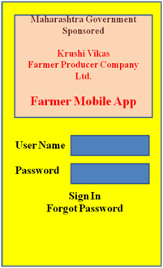 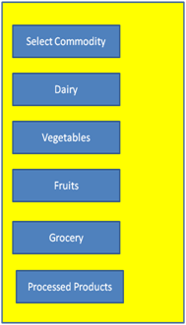

**Figure (a) Figure (b)**

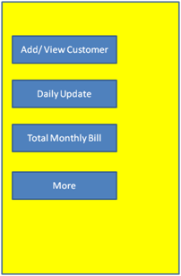 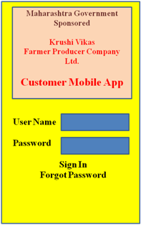

**Figure (c) Figure (d)**

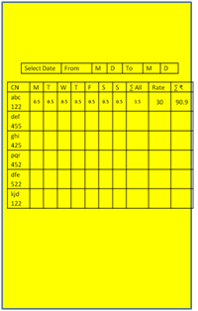 

**Figure (e) Figure (f)**

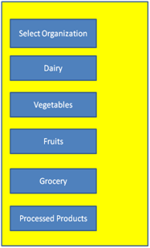 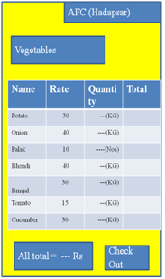

**Figure (g) Figure (h)**

**8. Representation of Proposed Mobile Application :**

a) Farmer Mobile Application

b) Available commodities

c) Dairy inputs

d) Addition of new customer

e) Data entry

f) Customer mobile application

g) Available commodities

h) Ordering vegetable tool.

**Mobile based application for customers associated with FC / FPC**

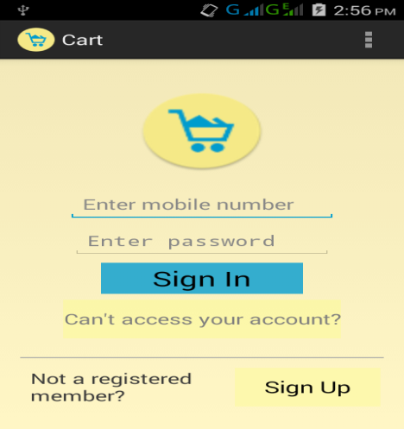 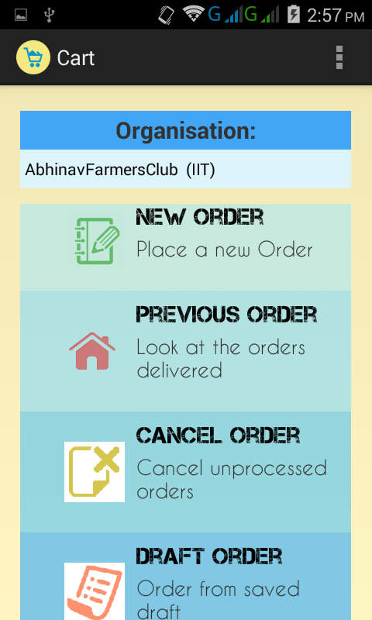

**Figure (a) Figure (b)**

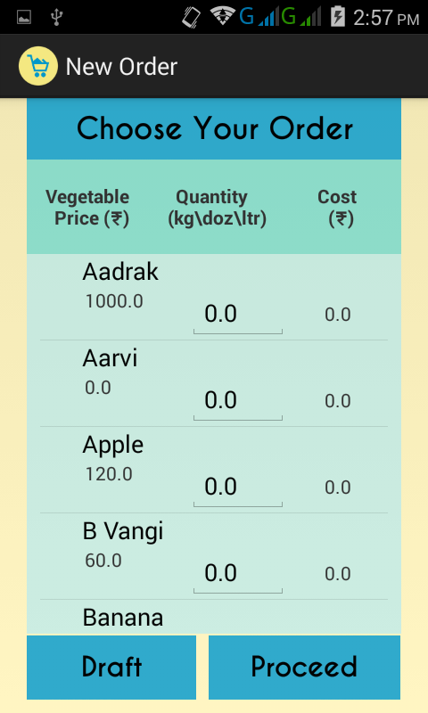 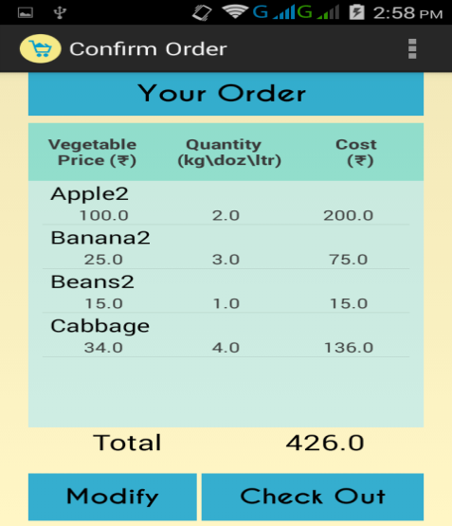

**Figure (c) Figure (d)**

**9. Representation of Proposed Web Application .**

**Web based FPC/FC user control/server :**

(a) Login Page

(b) Product Page

(c) Automated Bill

(d) SMS broadcast

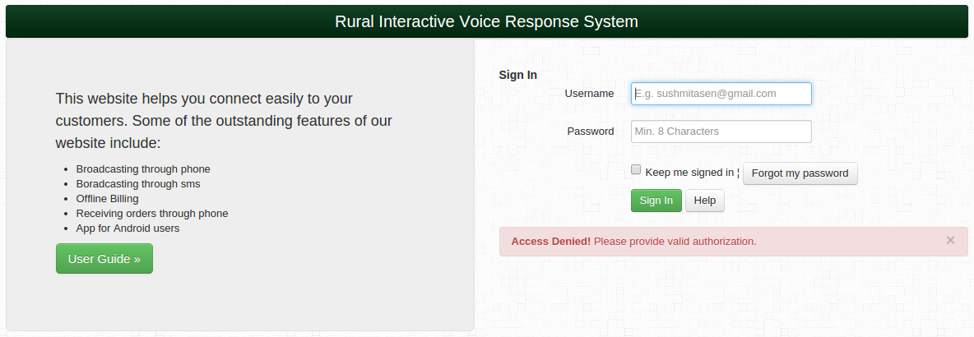

**Figure (a)**

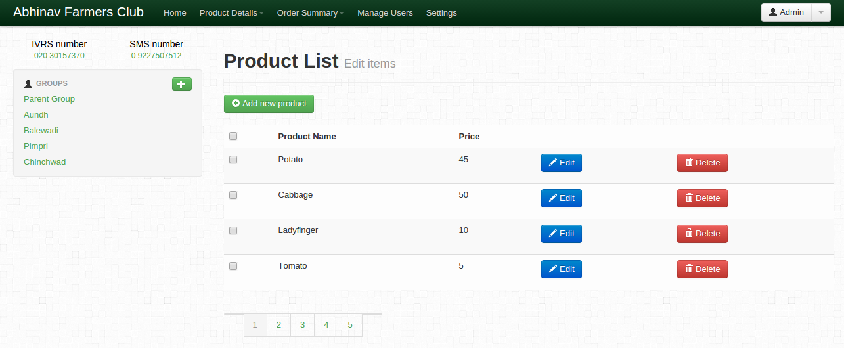

**Figure (b)**

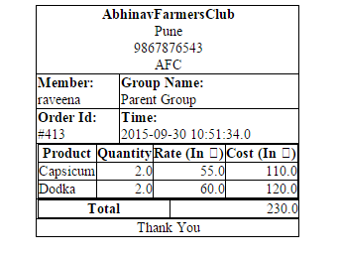

**Figure (c)**

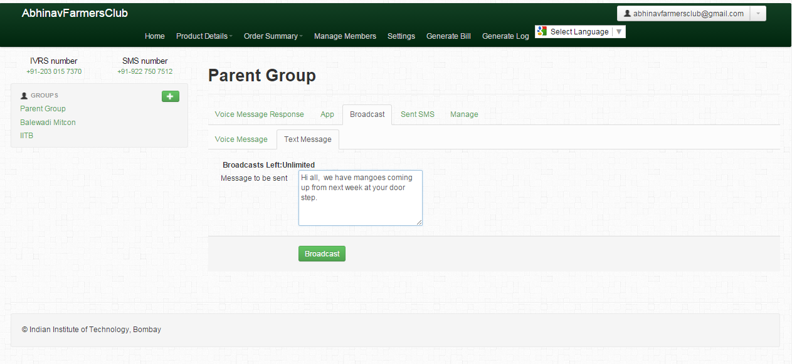

**Figure (d)**

**10. Conclusion**

The only sector which is not progressed in comparison to other sectors in India is agricultural sector as potential of IT deployment has not been fully exploited. On other hand, customers are willing to pay the good price to the products of farmer but the ineffective distribution system does not allow to reach the end users. i.e - the producer (farmers) and the customers.

There is enough potential available in FPC and FC to coordinate at least famers in radius of 50 KM from the city-centre. The case of two FPCs narrated demonstrate that ICT tool developed ie Mobile App can be further refined using agile-development methodology. This will also provide avenues for new entrepreneurship models as “service enablers” . While on one-hand, they will connect to customers and on the other hand they could co-ordinate with farmers to grow different crops with assured price and demands. This will go long way in ensuring sustenance of small-farming systems with additional source of income.

Our experience of working with the FPC and FC demonstrates the utility of this ICT tool to assist in marketing and building required synergy.

**11. References**

1. Itigi Prabhakar, et al, 2012, Farmers Producer Company — An Innovative Farmers’ Institution, Environment & Ecology 30 (2) : 427—430

2. E V Murray, 2008, Producer Company Model – Current Status and Future Outlook : Opportunities for Bank Finance, Financing Agriculture - A National Journal of Agriculture & Rural Development, vol 40

3. Lipton M, 2002, “Access to Assets and Land in the Context of Poverty Reduction and Economic Development in Asia”, paper presented at the Global Distance Learning Course, “Reaching the Rural Poor: Strategies for Rural Development for the East Asia Region”, Bangkok, 3-6 June.

4. N.H. Rao, 2007, A framework for implementing information and communication technologies in agricultural development in India , Technological Forecasting & Social Change, 74, 491–518

5. Page, S and R Slater, 2003, “Small Producer Participation in Global Food Systems: Policy Opportunities and Constraints”, Development Policy Review, 21(5-6): 641-54.

6. Ramesh Chand, Raka Saxena, Simmi Rana, 2015, Estimates and Analysis of Farm Income in India, 1983–84 to 2011–12, Economic & Political Weekly, vol l no 22

7. R. Venkattakumar and B.S. Sontakki, 2102, Producer Companies in India- Experiences and Implications , Indian Research Journal of Extension Education, Special Issue (Volume I)

8. Saravanan Raj, 2013, e-Agriculture Prototype for Knowledge Facilitation among Tribal Farmers of North-East India: Innovations, Impact and Lessons, Journal of Agricultural Education and Extension, Vol. 19, No. 2, 113_131

9. Sukhpal Singh, 2008, Producer companies as new Generation cooperatives, Economic and Political Weekly, Vol - XLIII No. 20

10. Sukhapal Singh, 2012, New Markets for Smallholders in India Exclusion, Policy and Mechanisms Economic & Political Weekly , vol xlvii no 52

11. T C A Ranganathan, (2015), Agricultural Oddities, EPW Economic & Political Weekly, vol l no 16